Room Mapping Robot Simulation

Tom Burrows

AQA A Level Computer Science NEA

Table of Contents

Analysis 1

Overview 1

Research Undertaken 1

Client 2

Objectives 2

Modelling Assumptions 3

Documented Design 4

Overall Structure 4

Software 5

HCI 5

Data Structures and Storage 9

Cartographer Algorithm 10

Database Design 10

Database Queries 11

Hardware API 12

Miscellaneous Notes 15

Technical Solution 17

Table of Contents 17

database_manager.py 18

hardware.py 19

cartographer.py 21

config_dialog.py 22

Demonstrations 23

Testing 25

Input Validation 25

Overall Functionality Tests 33

Platform Tests 42

Evaluation 46

Objectives Met 46

Extensibility / Potential for improvement 47

Client Feedback 48

Appendices 49

Appendix 1 – Client Interviews 49

# Analysis

## Overview

A robot is required to map a given room or series of rooms. Due to cost limitations, the robot will be implemented as a simulation program that imitates the imperfect readings that would be made from real sensors. Other advantages of doing it as a simulation program are that it allows easier testing of the mapping algorithms, and the user can experiment with different 'qualities' of hardware (i.e. how accurate the readings are) before actually purchasing it.

## Research Undertaken

The problem of how to map an environment whilst locating one's own position in it is known as SLAM (Simultaneous Localisation and Mapping). Both finding the location given a perfect map and mapping when the location is always known are fairly straightforward, but attempting to do both at once is much harder.

Initially I tried to design an algorithm that used a beacon in the centre of the room from which the robot could determine its distance. Combined with a Monte Carlo localisation algorithm[1] (also known as a particle filter), this could be used to determine where the robot is in relation to the beacon. I researched many different methods and technologies (including ultrasound, infrared, laser, bluetooth, wifi and image recognition) that could be used to determine the distance between the robot and the beacon, but I couldn't find any that would work with sufficient accuracy and range. Another disadvantage with this approach is that the robot can only work in range of the beacon, and for some technologies, needed to have a direct line of sight to it. This limits the overall usefulness of the robot.

I then abandoned this approach in favour of a complete SLAM algorithm that only requires the robot sensor and odometry data. Research into SLAM is still ongoing but there are existing algorithms that attempt to solve it. I discovered a SLAM algorithm based on existing ideas that I've researched[2], which was promising, but ultimately I decided against implementing a full SLAM algorithm, in favour of a simplified model.

For my robot, I am imitating a LIDAR Laser Range scanner[3] [4], which can take readings in 360˚ several times a second, and with quite high accuracy. Each product has a different range, accuracy (in mm or %) and angle resolution (<1˚ in higher end models), which my program will be able to simulate.

## Client

The client for this project is my father, who has an interest in DIY and robotics. He would find a room mapping robot useful when planning home improvements. See Appendix 1 for an interview with client.

## Objectives

1. When started, a GUI must open
   1. (Before it starts running) A button to open the configuration window
      1. An existing robot can be chosen
      2. A new robot can be created with different accuracy values
      3. A room is defined as a series of rectangle in form xpos, ypos, width, height, angle
      4. A preloaded room can be chosen
      5. A new room can be imported from a csv file
   2. (Before it starts running) A button to allow loading of a previously saved scan, to be resumed
   3. (Before it starts running) A start button that sends a 'start' command to the robot
   4. (While it is running) A stop button that stops the robot
   5. (While it is running or after it has finished running) A button to export the generated map to a format readable by an outside program (AutoCAD or similar, as specified by the client)
   6. (While it is running or after it has finished running) A button to save all details of the scan so far, to be able to be loaded later
2. 3 separate visualisation images must open, each displaying the environment in different ways
   1. The first is generated by the simulation showing
      1. The exact location and direction of the robot
      2. The exact locations of each object placed in the environment
   2. The second is generated by the robot algorithm showing
      1. The assumed location and direction of the robot
      2. The assumed location of each scan produced by the robot that iteration
      3. Any other point or line, as required by the algorithm
   3. The third is the map that has been generated so far
      1. Divided into a grid, each square of variable size
      2. Each square will be a shade of grey, from white meaning definitely unoccupied to black meaning definitely occupied
3. The robot algorithm must run on the PC/Laptop and must
   1. send control messages to the robot
   2. receive readings from the robot
   3. send current status updates to the visualisation program (2nd and 3rd maps)
4. The Robot must receive commands from the PC and act on them, returning the readings it makes
   1. It must be able to be run on a separate computer (i.e. a Raspberry Pi) that is on the same Wi-Fi network as the PC
   2. The details of how it becomes connected to the network is out of scope for this project
   3. For the purposes of this implementation, it will simulate it entirely from the PC
5. The simulation must implement the robot API
   1. The 'move forward' and 'rotate' commands must move the internal 'true' value by a 'fuzzed' amount, instead of what was actually passed in, imitating an actual motor and wheel set
   2. The 'get sensor readings' command must return 360 values, one for each degree, representing the distance from the robot to the first object in that direction, but 'fuzzed' to imitate an imperfect laser reading
   3. The simulation must also send the 'true' position of the robot to the visualisation program

## Modelling Assumptions

Because the program is a simulation (ie a model) of real life, certain modelling assumptions must be made about how the technology works:

1. All 4 sources of sensor inaccuracies will vary over the Normal (Gaussian) distribution, with the standard deviation of each able to be set individually for each robot.
   1. The raw distance to an object in a given direction
   2. The actual angle that the laser reading is being sent along
   3. The actual distance moved by the robot when instructed to move a certain distance
   4. The actual angle turned by the robot when instructed to turn through a certain angle
2. The errors from the robot moving and turning are not being accounted for by the robot’s algorithm, so if the standard deviation values are large, the resulting mapping will be inaccurate
3. The LIDAR scanner can measure any distance with equal percentage accuracy, so does not have a limited range
4. The robot can move through rectangles and will simply appear inside them. However, the robot will be blocked from exiting the room
5. The robot has 0 diameter, so all LIDAR readings will be measured as from the centre of the robot (see Documented Design > Miscellaneous Notes)
6. The robot movement happens instantaneously

# Documented Design

## Overall Structure

The following diagram demonstrates the overall program structure and the places where communication must happen between processes or separate parts of the program.

Orange = simulation information

Dotted = hardware specific implementation, not written as part of this project

Blue Rectangle = a separate thread

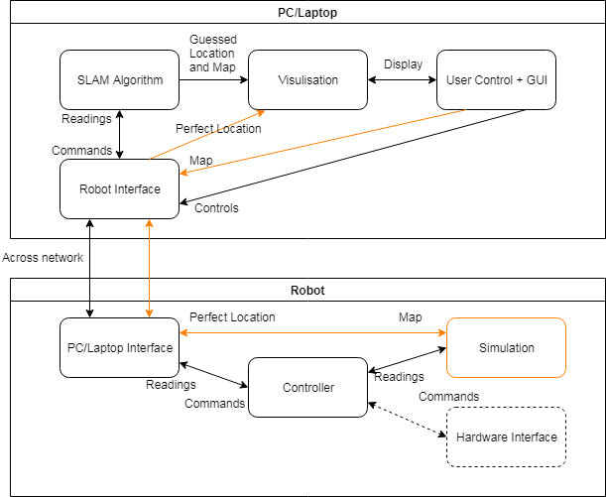

After further planning and design, I came up with a different structure, used in the final program:

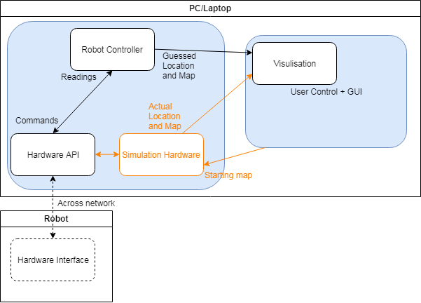

## Software

I will be developing this project using Python 3.6[5], using PyQt5[6] for the Graphical User Interface, and SQLite[7] (via the sqlite3 Python package) for the database. It is required to support Windows 10, but will be developed on macOS 10.14 Mojave.

## HCI

The following is an early mockup of what the GUI will look like:

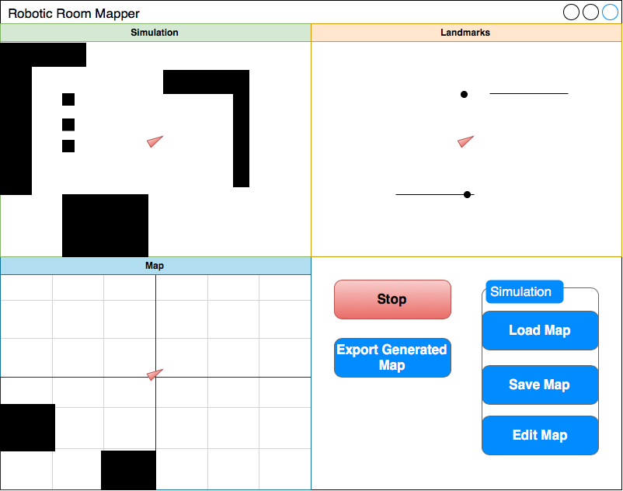

An annotated screenshot of the final GUI:

Room View

Discovered Map View

Scanner View



Robot controls

The diagram below explains the hierarchy of the Qt GUI, showing which object contains which, and which Qt class they inherit from.

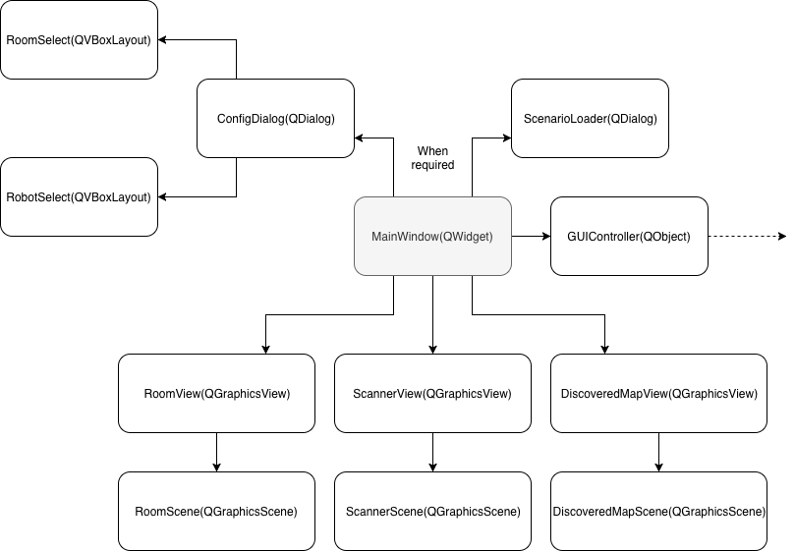

Below is the ConfigDialog popup window that appears when “Config Data” is pressed.

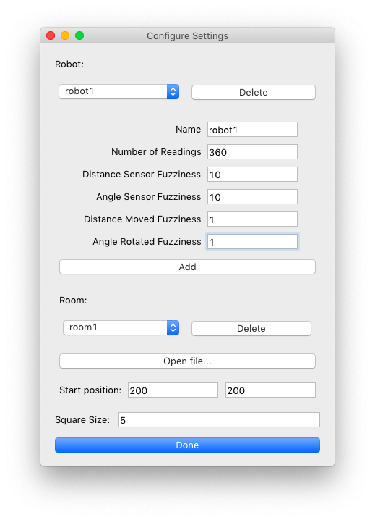

## Data Structures and Storage

###### General data

A point is universally stored as a tuple in the form (x, y).

Angles are all in degrees.

###### Rectangles

The simulation maps are stored as a list of tuples, each tuple representing a rectangle as (x,y, width,height,angle). Each rectangle is converted to 4 cartesian lines (each line is 2 points) by the scanner for easier processing.

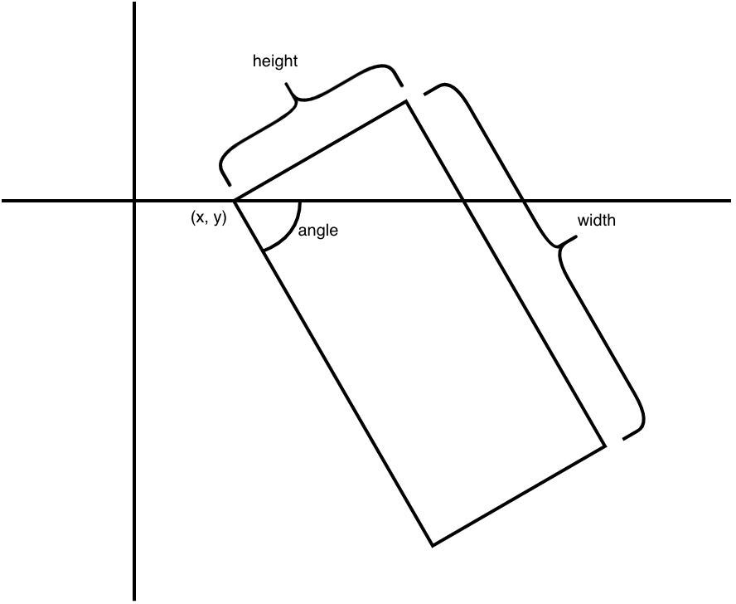

###### Rooms

Rooms are imported as csv files, where the first line contains the width and height of the room, and each subsequent line contains one rectangle:

width,height

x1,y1,width1,height1,angle1

x2,y2,width2,height2,angle2

x3,y3,width3,height3,angle3

e.g.

600,600  
0,0,100,100,0  
100,100,100,200,-10  
500,200,400,20,5  
300,500,10,300,30  
500,400,50,30,45

###### Queue

The main thread and the RobotController thread communicate via a queue, and Qt Signals. The queue is created in GUIController.run() and is used to send commands to the RobotController, which constantly checks for new commands, and acts upon them.

###### Cartographer

The Cartographer contains a grid, which is a 2-dimensional list. Each inner list represents a row of squares, and each item is a number representing whether that square is occupied or not, and how sure it is of that fact. 0 means that it does not know whether or not it is occupied. A positive value represents an occupied square, and a negative value represents an unoccupied square.

Each item in the grid is then passed through a sigmoid function[8], to convert it to a number between 0 and 1, which can be represented using different shades of grey.

## Cartographer Algorithm

Given a grid (see directly above), the robot’s current position, and a list of observed points and a value of ‘square size’ (how large each square on the grid is) this method updates the grid to take into account the new information. It considers one point at a time.

* Given one point:
  + Find the gradient and y intercept of the line going from position to point
  + Store the x values of position, point and all x values on column boundaries between the two
  + For each x value in the above list, consider that one and the one after it
  + Use the gradient and y intercept to calculate the y values when it enters and exits this column
  + Update each grid square using the current x value and all y values between the two just calculated, decreasing their weight
  + Finally, update the grid square that contains point to increase its weight

## Database Design

The following diagram shows the tables and fields used. Each Room is stored as a width, height, and lots of Rectangles, that are ‘owned’ by a specific room.

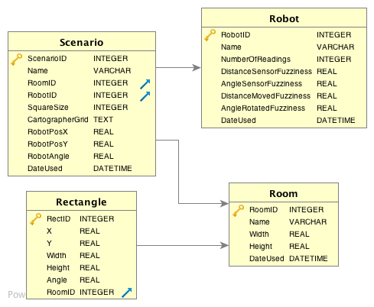

So it can be seen that one Room can have lots of Rectangles, and lots of Scenarios, and one Robot can have lots of Scenarios. The SQL commands to generate the above database can be found in Appendix 2.

## Database Queries

The program will need to be able to insert and retrieve data from the database. Here follows a selection of commands to be used:

|  |  |  |  |
| --- | --- | --- | --- |
| Command | Parameters | Return Values | Usage |
| SELECT Width, Height FROM Room WHERE Name = ?; | Name | Width, Height [single] | Get the width and hight of a given room |
| SELECT Name FROM ? ORDER BY DateUsed DESC; | TableName | Name [many] | Gets all rows in a given table, in order of when they were last used |
| UPDATE ? SET DateUsed=DATETIME('now') WHERE Name = ?; | TableName, RecordName | n/a | Set the DateUsed field of a specific record |
| SELECT Rectangle.X, Rectangle.Y, Rectangle.Width, Rectangle.Height, Rectangle.Angle FROM Rectangle INNER JOIN Room ON Rectangle.RoomID=Room.RoomID WHERE Room.Name = ?; | RoomName | X, Y, Width, Height, Angle [many] | Gets all rectangles associated with RoomName |
| INSERT INTO Scenario VALUES (Null, ?, (SELECT RoomID FROM Room WHERE Name = ?), (SELECT RobotID FROM Robot WHERE Name = ?), ?, ?, ?, ?, ?, DATETIME('now')); | ScenarioName, RoomName, RobotName, SquareSize, CartographerGrid [json-dumped list], RobotX, RobotY, RobotAngle | n/a | Inserts a single scenario. Uses inline SELECT statements to get the RoomID and RobotID |
| SELECT Robot.Name, Room.Name, Scenario.SquareSize, Scenario.CartographerGrid, Scenario.RobotPosX, Scenario.RobotPosY, Scenario.RobotAngle FROM Scenario INNER JOIN Robot on Robot.RobotID=Scenario.RobotID INNER JOIN Room on Room.RoomID=Scenario.RoomID WHERE Scenario.Name = ?; | ScenarioName | RobotName, RoomName, SquareSize, CartographerGrid [json-dumped list], RobotX, RobotY, RobotAngle [single] | Gets all data needed to load a scenario |
| DELETE FROM Robot WHERE Name = ?; | RobotName | n/a | Deletes RobotName |
| DELETE FROM Rectangle WHERE RoomID = (SELECT RoomID FROM Room WHERE Name = ?); | RoomName | n/a | Deletes all rectangles associated with RoomName |
| DELETE FROM Room WHERE Name = ?; | RoomName | n/a | Deletes RoomName |
| DELETE FROM Scenario WHERE Name = ?; | ScenarioName | n/a | Deletes ScenarioName |

All interactions with the database are done through the DatabaseManager object, which is instantiated where needed.

## Hardware API

The robot API must be fixed so that when implementing it for a physical piece of hardware, the class can be dropped in place, using the following API:

|  |  |  |  |
| --- | --- | --- | --- |
| Public Methods | Parameters | Return Values | Description |
| __init__ | initial_position, inital_angle, map_size, rects, config_values, position_changed_signal, rotation_changed_signal | n/a | Assign position_changed_signal and rotation_changed_signal as attributes of self. Pass the rest of the parameters to _Scanner() and _Odometer() |
| scan | n/a | distances - dict, keys are angles, values are distances | Make a scan of the environment.  For each angle, finds the distance between the robot and the nearest object in that direction.  The angles and distances are fuzzed. |
| move_forward | distance | n/a | Move the robot the distance specified.  'Odometry' data will return how much it thinks the robot moved by. This distance is fuzzed. |
| rotate | angle | n/a | Turn the robot the angle specified.  'Odometry' data will return how much it thinks the robot turned by. This angle is fuzzed. |

My hardware implementation uses the objects _Scanner() and _Odometer():

###### Scanner

|  |  |
| --- | --- |
| Attributes | Type |
| position | tuple of 2 ints |
| rotation | float |
| lines | list of lines |
| room_size | tuple of 2 ints (w, h) |

|  |  |  |  |
| --- | --- | --- | --- |
| Methods | Parameters | Return Values | Description |
| __init__ | room_size - tuple of 2 ints (w, h)  lines  initial_position - tuple of 2 ints | n/a | Save all parameters into attributes. |
| scan | current_position - pos | distances - dict, keys are angles, values are distances | See Hardware.scan()  Get angles_dict from self._find_angles().  For each angle to scan, apply fuzziness, then self._find_shortest_intersection() with it. Return results in dict. |
| _find_angle | end - pos | angle - int | Return the angle from 0˚ to the line self.position -> end |
| _find_angles | n/a | angles - dict, keys are values of self.lines, values are tuples of 2 angles | Work out the angle to the start and end of each line in the room with self._find_angle |
| _find_intersection | angle - int  p1 - pos  p2 - pos | distance - int | Find the point on the wall p1 -> p2 that intersects with the incident ray from self.position at angle, then return the fuzzed length of this incident ray |
| _find_shortest_intersection | angle - int  lines - dict | distance - int | Iterate over lines. If angle is within the bounds for the line, get the distance to that line with self._find_intersection().  Return the minimum distance found. |

Geometric equations for above functions:

_find_angle():

$θ=\arctan\left(\frac{y_{end}-y_{start}}{x_{end}-x_{start}}\right)$

_find_intersection():

$$m_{incident}=\tan\left(θ\right)$$

$$m_{wall}=\frac{y_{2}-y_{1}}{{x_{2}-x}_{1}}$$

$$x=\frac{y_{1 }-x_{1}m_{wall}+y_{start}m_{incident}-x_{start}}{m_{incident}-m_{wall}}$$

$$y=m_{wall}\left(x-x_{1}\right)+y_{1}$$

$$length=\sqrt{{\left(x-x_{start}\right)}^{2}+{\left(y-y_{start}\right)}^{2}}$$

###### Odometer

|  |  |
| --- | --- |
| Attributes | Type |
| position | pos |
| rects | list of rects |
| room_size | tuple of 2 ints (w, h) |

|  |  |  |  |
| --- | --- | --- | --- |
| Methods | Parameters | Return Values | Description |
| __init__ | room_size - tuple of 2 ints (w, h)  lines  initial_position - tuple of 2 ints | n/a | Save all parameters into attributes. |
| move_forward | distance - int | distance_moved, actual_distance_moved | move distance |
| rotate | angle - int | angle_rotated, actual_angle_rotated | turn by angle |

## Miscellaneous Notes

The robot dimensions consist of 2 parts: the radius of the sensor array and the radius of the entire robot. Both of these values must be accounted for if the program is to be successful. The sensor array diameter is the distance between the start of the measurements in one direction to the start of the measurement in the opposite direction. This must be accounted for by the driver interfacing between the sensor and the program. For the purposes of the robot algorithm, all readings are treated as if they come from an infinitesimally small point at the centre of the sensor array.

The robot algorithm and the simulation will use a standard cartesian coordinate system with (0,0) in the bottom left, positive x and y going right and up, and negative x and y going left and down. The GUI (including visualisation) will use the system common in computer graphics, where (0,0) is in the upper left corner and positive x and y are right and down. The GUI program will convert between the two systems by calling geometry_utils.mirror_y() immediately as each co-ordinate is passed to PyQt.

# Technical Solution

The full program can be found in Appendix 3.

The file structure is below:

│ main.py

﻿│ robot_controller.py

│ hardware.py

│ cartographer.py

│ database_manager.py

│ database.db

│

├───gui_files

│ main_window.py

│ gui_controller.py

│ room_window.py

│ scanner_window.py

│ discovered_map_window.py

│ config_dialog.py

│ scenario_loader.py

│

│

└───utilities

geometry_utils.py

degree_math.py

## Table of Contents

|  |  |
| --- | --- |
| File Name | Contents |
| main.py | Calls main_window.main(). Starts program |
| robot_controller.py | RobotController()  Controls what the robot does, and what it sends to the visualisation windows |
| hardware.py | Hardware(), _Scanner(), _Odometer()  Simulates real hardware |
| cartographer.py | Cartographer()  Keeps track of the probabilities of each square being occupied |
| database_manager.py | DatabaseManager()  Interface for the database |
| main_window.py | MainWindow()  Holds together all other QWidgets. Controls ConfigDialog() and ScenarioLoader() |
| gui_controller.py | GUIController()  Prepares MapWindow |
| room_window.py | RoomView(), RoomScene()  Shows the room that the robot is exploring |
| scanner_window.py | ScannerView(), ScannerScene()  Shows the scans that the robot is making |
| discovered_map_window.py | DiscoveredMapView(), DiscoveredMapScene()  Shows the grid that the robot has explored |
| config_dialog.py | ConfigDialog(), RobotSelect(), RoomSelect()  The dialog window that opens when choosing which robot and room to use |
| scenario_loader.py | ScenarioLoader()  The dialog window that opens when choosing which scenario to load |
| geometry_utils.py | mirror_y(), rect_to_points(), generate_lines()  Assorted simple algorithms/formulas for coordinate manipulation |
| degree_math.py | sin(), cos(), tan(), atan()  Redefining some trigonometric functions to use degrees instead of radians |

Featured here are some of the more interesting files:

## database_manager.py

This file contains the object DatabaseManager, which controls all access to the database, and generates all SQL queries. Of particular note is get_scenario_by_name(), which uses INNER JOIN statements, and add_scenario() which uses inline SELECT statements and a method of adding a number to the end of the name if the name already exists in the database.

**def** get_scenario_by_name(self, scenario_name):

command = "SELECT Robot.Name, Room.Name, Scenario.SquareSize, " \

"Scenario.CartographerGrid, Scenario.RobotPosX, " \

"Scenario.RobotPosY, Scenario.RobotAngle " \

"FROM Scenario " \

"INNER JOIN Robot on Robot.RobotID=Scenario.RobotID " \

"INNER JOIN Room on Room.RoomID=Scenario.RoomID " \

"WHERE Scenario.Name = ?;"

scenario_data = self.connection.execute(command, (scenario_name,))

.fetchone()

**return** scenario_data

**def** add_scenario(self, scenario_name, room_name, robot_name, square_size, cartographer_grid, robot_x, robot_y, robot_angle):

command = "INSERT INTO Scenario VALUES (Null, ?," \

"(SELECT RoomID FROM Room WHERE Name=?)," \

"(SELECT RobotID FROM Robot WHERE Name=?)," \

"?, ?, ?, ?, ?, DATETIME('now'));"

**try**:

self.connection.execute(command, (scenario_name,

room_name, robot_name, square_size,

json.dumps(cartographer_grid),

robot_x, robot_y, robot_angle))

**except** sqlite3.IntegrityError:

iteration = 2

**while** True:

extended_scenario_name = scenario_name + f"({iteration})"

**try**:

self.connection.execute(command,

(extended_scenario_name, room_name, robot_name,

square_size, json.dumps(cartographer_grid),

robot_x, robot_y, robot_angle))

**except** sqlite3.IntegrityError:

iteration += 1

self.connection.commit()

## hardware.py

The object Hardware uses composition to own a _Scanner and a _Odometer.

The algorithm used by _Scanner.scan is detailed in Documented Design > Hardware API > Scanner

**class** _Scanner:

**def** __init__(self, room_size, rects, initial_position,

number_of_readings, sensor_reading_fuzziness,

sensor_angle_fuzziness):

self.room_size = room_size

self.position = initial_position

self.sensor_angle_fuzziness = sensor_angle_fuzziness

self.sensor_reading_fuzziness = sensor_reading_fuzziness

self.number_of_readings = number_of_readings

self.lines = generate_lines(rects, room_size)

**def** scan(self, current_position):

self.position = current_position

angles_dict = self._find_angles()

distances_dict = {}

**for** i **in** range(self.number_of_readings):

angle = i * (360/self.number_of_readings)

angle = gauss(angle, self.sensor_angle_fuzziness)

**if** angle >= 180:

angle -= 360

**if** angle <= -180:

angle += 360

distance = self._find_shortest_intersection(angle, angles_dict)

distances_dict[angle] = distance

**assert** len(distances_dict) != 0

**return** distances_dict

**def** find_angle(self, end):

"""

        Finds the angle between 0˚ and the line from self.position to end

        """

start = self.position

**while** start == end:

start = start[0] - 0.001, start[1] - 0.001

**if** start[0] == end[0]:

**if** end[1] > start[1]:

angle = 90

**else**:

angle = -90

**else**:

angle = atan((end[1] - start[1]) / (end[0] - start[0]))

**if** start[0] > end[0]:

# Then it is greater than 90˚ or less than -90˚

**if** end[1] >= start[1]: # Then it is in the 2nd quadrant

angle += 180

**elif** end[1] < start[1]:

angle -= 180

**return** angle

**def** _find_angles(self):

"""

        Work out the angle to the start and end of each line in the room

        """

angles_dict = {}

**for** line **in** self.lines:

angle1 = self.find_angle(line[0])

angle2 = self.find_angle(line[1])

# Swap them around if they are the wrong way around

**if** angle2 < angle1:

angle1, angle2 = angle2, angle1

angles_dict[line] = (angle1, angle2)

**return** angles_dict

**def** _find_intersection(self, angle, p1, p2):

"""

        Finds the point on the wall p1 -> p2 that intersects with the

incident ray pos at angle theta, and the length of the incident ray

        """

m_incident = tan(angle)

# First do edge case where m_wall == infinity

**if** p2[0] == p1[0]:

x = p1[0]

# y = m(x-x_1) + y_1

y = m_incident * (x - self.position[0]) + self.position[1]

**else**:

m_wall = (p2[1] - p1[1]) / (p2[0] - p1[0])

x = (p1[1] - p1[0] * m_wall + self.position[0]

* m_incident - self.position[1]) / (m_incident - m_wall)

y = m_wall * (x - p1[0]) + p1[1]

length = sqrt((x - self.position[0])**2 +(y - self.position[1])**2)

length = gauss(length, self.sensor_reading_fuzziness)

**return** length

**def** _find_shortest_intersection(self, angle, angles_dict):

lengths = []

**for** line **in** angles_dict:

angles = angles_dict[line] # angles is a tuple, length 2

# Allow for the fact that some angles go over

# between -180 and 180

**if** abs(angles[1] - angles[0]) > 180:

**if** angles[0] >= angle **or** angles[1] <= angle:

length_to_line = self._find_intersection(angle, *line)

lengths.append(length_to_line)

**elif** angles[0] <= angle <= angles[1]:

length_to_line = self._find_intersection(angle, *line)

lengths.append(length_to_line)

**if** len(lengths) == 0:

**raise** ValueError(f"No lines to collide with at angle {angle}")

**return** min(lengths)

## cartographer.py

Cartographer.update():

Given a grid (see Documented Design > Data Structures and Storage > Cartographer), the robot’s current position, and a list of observed points, this method updates the grid to take into account the new information. It considers one point at a time. See Documented Design > Cartographer Algorithm for an explanation of how it works.

**def** update(self, position, points):

**for** point **in** points:

from_x = min(point[0], position[0])

to_x = max(point[0], position[0])

m, y_int = equation_of_line(point, position)

# Generate x values to use

start = [from_x]

mid_section = range(ceil(from_x / self.square_size),

int(to_x // self.square_size))

apply_square_size = **lambda** x: x * self.square_size

mid_section = list(map(apply_square_size, mid_section))

end = [to_x]

x_values = start + mid_section + end

**for** i **in** range(len(x_values)-1):

# Go through each x value at regular y values

start_y = m * x_values[i] + y_int

end_y = m * x_values[i+1] + y_int

**if** start_y > end_y:

start_y, end_y = end_y, start_y

**for** y **in** range(int(start_y//self.square_size),

int(end_y//self.square_size+1)):

# For each y value in between 2 x values...

x = int(x_values[i]//self.square_size)

**if** x < 0 **or** y < 0 **or** x >= self.width **or** y >= self.height:

# Point is outside our large rectangle, so ignore it

**continue**

self.grid[y][x] -= self.INCREASE_AMOUNT

# Mark the finish point, but bear in mind that it has already

# been subtracted once

x = int(point[0] // self.square_size)

y = int(point[1] // self.square_size)

**if** x < 0 **or** y < 0 **or** x >= self.width **or** y >= self.height:

**continue**

self.grid[y][x] += 5 * self.INCREASE_AMOUNT

self.sigmoid_grid = [list(map(logistic, row)) **for** row **in** self.grid]

self.callback_signal.emit(self.sigmoid_grid)

## config_dialog.py

ConfigDialog.validate_values() demonstrates extremely defensive programming, when dealing with user input.

**def** validate_values(self, x, y, robot_dropdown_text, room_dropdown_text, square_size):

# room_dropdown_text must not be empty

**if** room_dropdown_text == "":

**return** False

# robot_dropdown_text must not be empty

**if** robot_dropdown_text == "":

**return** False

width, height = self.database.

get_room_width_height_by_room_name(room_dropdown_text)

# x must be a positive integer between 0 and <width>

**try**:

x = int(x)

**except** ValueError:

**return** False

**if** x <= 0 **or** x >= width:

**return** False

# y must be a positive integer between 0 and <width>

**try**:

y = int(y)

**except** ValueError:

**return** False

**if** y <= 0 **or** y >= height:

**return** False

# square_size must be an integer that is a factor of both

# width and height and < 0

**try**:

square_size = int(square_size)

**except** ValueError:

**return** False

**if** square_size <= 0:

**return** False

**if** width % square_size != 0:

**return** False

**if** height % square_size != 0:

**return** False

**return** True

## Demonstrations

Varying the different configuration settings, gives quite different results (all shown here after 5 readings):

Both Sensor Fuzziness = 10, Square Size = 5



Sensor Fuzziness = 0, Square Size = 4Distance Sensor Fuzziness = 20, Angle Sensor Fuzziness = 15, Square Size = 5 

# Testing

## Input Validation

The user input can come in the following ways:

###### CSV Room Files

The CSV files must be in a specific format, as specified in Documented Design > Data Structures and Storage (see right). If the files are incorrect, the file must be rejected. The file is imported and validated in gui_files/config_dialog.py: RoomSelect.open_file().

width,height

x1,y1,width1,height1,angle1

x2,y2,width2,height2,angle2

x3,y3,width3,height3,angle3

Any rectangles that are outside the room space are allowed, but they won’t be displayed. Rooms with no rectangles, or overlapping rectangles is still valid.

|  |  |  |
| --- | --- | --- |
| Data | Type | Further Restrictions |
| Room Width | integer | 10 ≤ width ≤ 800, not empty |
| Room Height | integer | 10 ≤ height ≤ 800, not empty |
| X | integer | > 0, not empty |
| Y | integer | > 0, not empty |
| Rectangle Width | integer | > 0, not empty |
| Rectangle Height | integer | > 0, not empty |
| Angle | integer | not empty |

|  |  |  |  |
| --- | --- | --- | --- |
| Test explanation | File | Should be accepted? | Test passed? |
| Valid data | 400,400 | Yes | Yes |
| 400,400  100,100,100,100,0  300,200,50,50,10 | Yes | Yes |
| 400,400  100,100,100,100,0  300,200,50,50,-40 | Yes | Yes |
| 400,400  100,100,100,100,0  300,200,50,50,134 | Yes | Yes |
| Incorrect room width/height formatting | 400 400 | No | Yes |
| 400,400,400 | No | Yes |
| 400,test  100,100,100,100,10 | No | Yes |
| Incorrect rectangle formatting | 400,400  100,100,100,100,10  test | No | Yes |
| 400,400  100,200,300,400 | No | Yes |
| 400,400  100,200,20,10,30  100,40,20,10 | No | Yes |
| 400,400  100,200,20,10,30  100,40,20,1045 | No | Yes |
| Size values near/outside range | 11,400 | Yes | Yes |
| 10,400 | Yes | Yes |
| 9,400 | No | Yes |
| 0,400 | No | Yes |
| -10,400 | No | Yes |
| 799,400 | Yes | Yes |
| 800,400 | Yes | Yes |
| 801,400 | No | Yes |
| 400,11 | Yes | Yes |
| 400,10 | Yes | Yes |
| 400,9 | No | Yes |
| 400,0 | No | Yes |
| 400,-10 | No | Yes |
| 400,799 | Yes | Yes |
| 400,800 | Yes | Yes |
| 400,801 | No | Yes |
| Rectangle Values outside range | 400,400  -100,200,20,10,30 | No | Yes |
| 400,400  100,-200,20,10,30 | No | Yes |
| 400,400  100,200,-20,10,30 | No | Yes |
| 400,400  100,200,20,-10,30 | No | Yes |
| 400,400  100,200,20,10,-30 | Yes [angles can be negative] | Yes |
| Empty file |  | No | Yes |

###### Robot Dialog Form

There are several fields present in ConfigDialog, where the user is free to type any value.

|  |  |  |
| --- | --- | --- |
| Field Name | Type | Further Restrictions |
| Name | string | not empty |
| Number of Readings | integer | 0 < x < 720, not empty |
| Distance Sensor Fuzziness | float | ≥ 0, not empty |
| Angle Sensor Fuzziness | float | ≥ 0, not empty |
| Distance Moved Fuzziness | float | ≥ 0, not empty |
| Angle Rotated Fuzziness | float | ≥ 0, not empty |

When the text in a QLineEdit changed, a signal is called, which is connected to validation functions. If the text is not valid, the ‘submit’ button is disabled and greyed out. The dialog has two separate input forms:

* Add Robot contains Name, Number of Readings and 4 Fuzziness values
  + When any of these are edited, RobotSelect.validate() is called, which disables RobotSelect.add_robot_button() if any of the QLineEdits are not valid

Robot Test Cases:

|  |  |  |  |  |  |  |  |
| --- | --- | --- | --- | --- | --- | --- | --- |
| Name | Number of Readings | Distance Sensor Fuzziness | Angle Sensor Fuzziness | Distance Moved Fuzziness | Angle Rotated Fuzziness | Should be accepted? | Test passed? |
| test1 | 360 | 10 | 10 | 1 | 1 | Yes | Yes [see screenshot] |
| test2 | 360 | hello | 1 | 1 | 1 | No | Yes [see screenshot] |
|  | 360 | 10 | 10 | 1 | 1 | No | Yes |
| test4 | 720 | 10 | 10 | 1 | 1 | Yes | Yes |
| test5 | 721 | 10 | 10 | 1 | 1 | No | Yes |
| test6 | 1 | 10 | 10 | 1 | 1 | Yes | Yes |
| test7 | 0 | 10 | 10 | 1 | 1 | No | Yes |
| test8 | -5 | 10 | 10 | 1 | 1 | No | Yes |
| test9 | hello | 10 | 10 | 1 | 1 | No | Yes |
| test10 | 90 | 0.1 | 0.3 | 0 | 4 | Yes | Yes |
| test11;’:/#3á | 360 | 1 | 1 | 1 | 1 | Yes | Yes |
| test12 | 180 | 0 | 0.0 | 10000 | 1234.56 | Yes | Yes |
| test13 | 90 | -4 | 2 | 2 | 2 | No | Yes |





###### Room Select Form

All five inputs are connected to ConfigDialog.validate_input(), so whenever any of them are updated, all inputs are checked, and if any are invalid, the final button is disabled, and cannot be clicked.

|  |  |  |
| --- | --- | --- |
| Field Name | Type | Further Restrictions |
| Robot Name (from dropdown) | string | must be found in the database |
| Room Name (from dropdown) | string | must be found in the database |
| Start Position X | integer | 0 < X < Room Width, not empty |
| Start Position Y | integer | 0 < Y < Room Height, not empty |
| Square Size | integer | > 0, must be a factor of both Width and Height, not empty |

Because it is impossible to select rooms and robots that do not exist from the drop down menus, the following test cases assume they are valid. The exception to this is the blank name, which is selected when no records are found in the database.

The following robot is placed in the database before testing:

|  |  |  |  |  |  |
| --- | --- | --- | --- | --- | --- |
| Name | Number of Readings | Distance Sensor Fuzziness | Angle Sensor Fuzziness | Distance Moved Fuzziness | Angle Rotated Fuzziness |
| robot1 | 360 | 10 | 10 | 1 | 1 |

The following rooms are placed in the database (note: input validation when importing the csv files is covered elsewhere, and details of which rectangles are in these rooms is not relevant)

|  |  |  |
| --- | --- | --- |
| Name | Width | Height |
| room1 | 500 | 500 |
| room2 | 600 | 400 |

|  |  |  |  |  |  |  |  |
| --- | --- | --- | --- | --- | --- | --- | --- |
| Test Explanation | Robot Name | Room Name | Start Position X | Start Position Y | Square Size | Should be accepted? | Test passed? |
| Typical Data | robot1 | room1 | 250 | 250 | 10 | Yes | Yes |
| Start Position X boundary and invalid data | robot1 | room1 | 1 | 250 | 10 | Yes | Yes |
| robot1 | room1 | 0 | 250 | 10 | No | Yes |
| robot1 | room1 | -1 | 250 | 10 | No | Yes |
| robot1 | room1 | 499 | 250 | 10 | Yes | Yes |
| robot1 | room1 | 500 | 250 | 10 | No | Yes |
| robot1 | room1 | 501 | 250 | 10 | No | Yes |
| Start Position Y boundary and invalid data | robot1 | room1 | 250 | 1 | 10 | Yes | Yes |
| robot1 | room1 | 250 | 0 | 10 | No | Yes |
| robot1 | room1 | 250 | -1 | 10 | No | Yes |
| robot1 | room1 | 250 | 499 | 10 | Yes | Yes |
| robot1 | room1 | 250 | 500 | 10 | No | Yes |
| robot1 | room1 | 250 | 501 | 10 | No | Yes |
| Missing data |  | room1 | 250 | 250 | 10 | No | Yes |
| robot1 |  | 250 | 250 | 10 | No | Yes |
| robot1 | room1 |  | 250 | 10 | No | Yes |
| robot1 | room1 | 250 |  | 10 | No | Yes |
| robot1 | room1 | 250 | 250 |  | No | Yes |
| Square Size boundary and invalid data | robot1 | room1 | 250 | 250 | 500 | Yes | Yes |
| robot1 | room1 | 250 | 250 | 1 | Yes | Yes |
| robot1 | room1 | 250 | 250 | 2 | Yes | Yes |
| robot1 | room1 | 250 | 250 | 9 | No | Yes |
| robot1 | room1 | 250 | 250 | 0 | No | No (Application crash)  After fix: Yes |
| robot1 | room1 | 250 | 250 | -1 | No | No (Accepted as valid)  After fix: Yes |
| robot1 | room1 | 250 | 250 | -10 | No | No (Accepted as valid)  After fix: Yes |
| Different room width and height | robot1 | room2 | 200 | 200 | 10 | Yes | Yes |
| robot1 | room2 | 200 | 200 | 80 | No | Yes |
| robot1 | room2 | 200 | 200 | 1 | Yes | Yes |

3 test cases failed (when square size <= 0) due to missing validation check. After the fix, all test cases were retested, and all passed.

## Overall Functionality Tests

Now the program is complete, I demonstrate and test as many critical paths through the software as possible.

|  |  |  |
| --- | --- | --- |
| Explanation | Expected Outcome(s) | Actual Outcome(s) |
| Load room1.csv and create a robot (360 readings, 3 sensor fuzziness, 0 movement fuzziness), then start. | Configure Settings window looks normal.  The left window displays the room, the middle window displays dots roughly where the visible walls are, and the right window displays its interpretation of the reading, with the visible walls faintly visible. | As expected. |
|  | | |
| Drive forward 5 times. | The robot icon has moved up in both the left and middle windows. The map on the right shows the room much better. | As expected, except the robot icons in the middle are not cleared each time. Second screenshot shows same test after fix is applied. |
|  | | |
|  | | |
| Drive around the room until it has all been visited. | The map on the right shows a very accurate representation of the map on the left | As expected. |
|  | | |
| Export the map into ‘saved_map.png’. Open in external image viewer. | An exact copy of the right window is saved into the image file. | As expected. |
|  | | |
| Save the scenario as ‘test_scenario’. Then restart the program and load it back in. | The scenario is loaded back in exactly as it was left before. | As expected. |
|  | | |
| Drive around a little bit more. Stop the scenario, click ‘Setup’ and select a different robot and room. Then start it with the new setup. | Configure Settings window should look as it did when we set it at the start. The new scenario behaves normally. | The Start Position fields incorrectly show the current position of the robot, not the last-set start position.  Second screenshot shows correct settings window after a fix has been applied.  Third screenshot shows the new room, which is loaded as expected. |
|  | | |

It can therefore be seen that the program works as intended for normal use.

## Platform Tests

The program must run on both macOS and Windows 10, so all functionality tests have been run on both platforms to ensure cross compatibility.

Windows test screenshots:

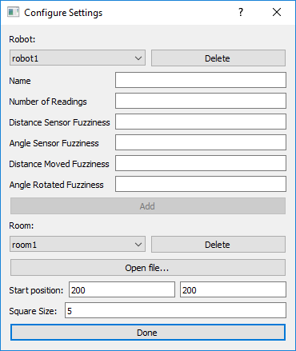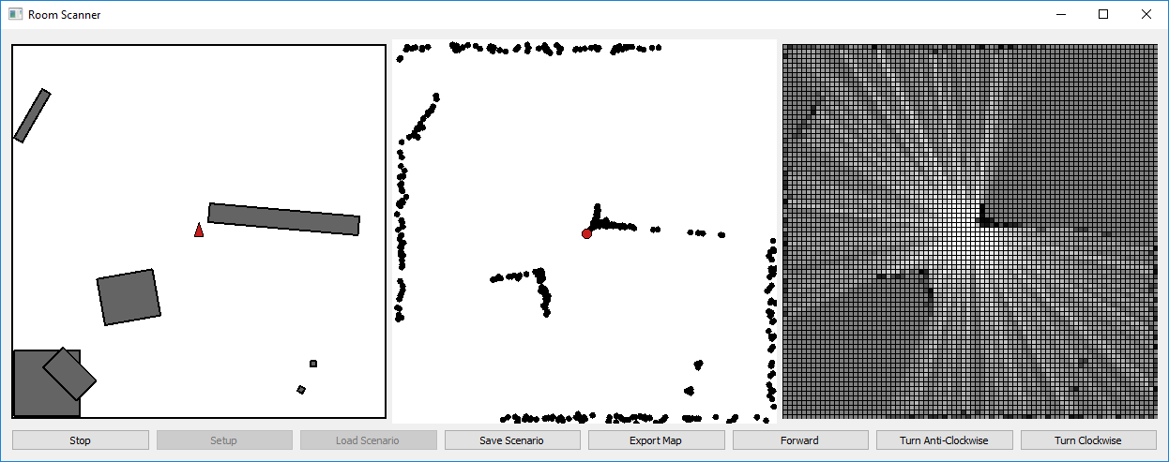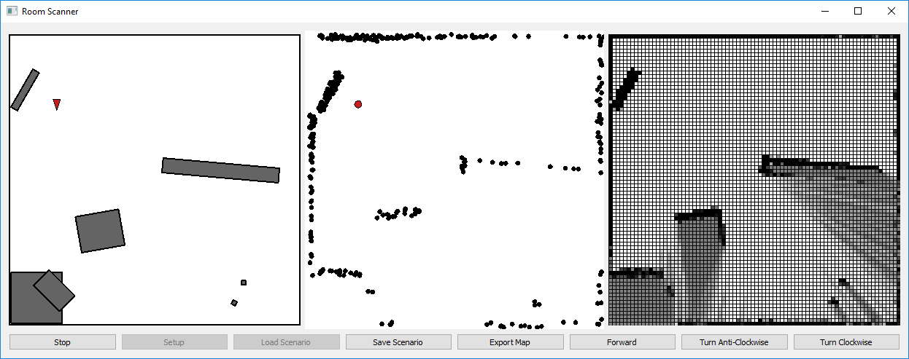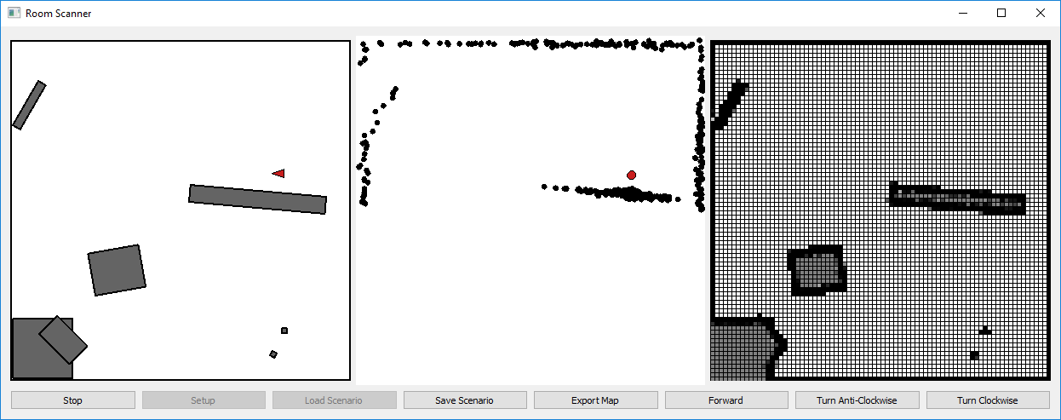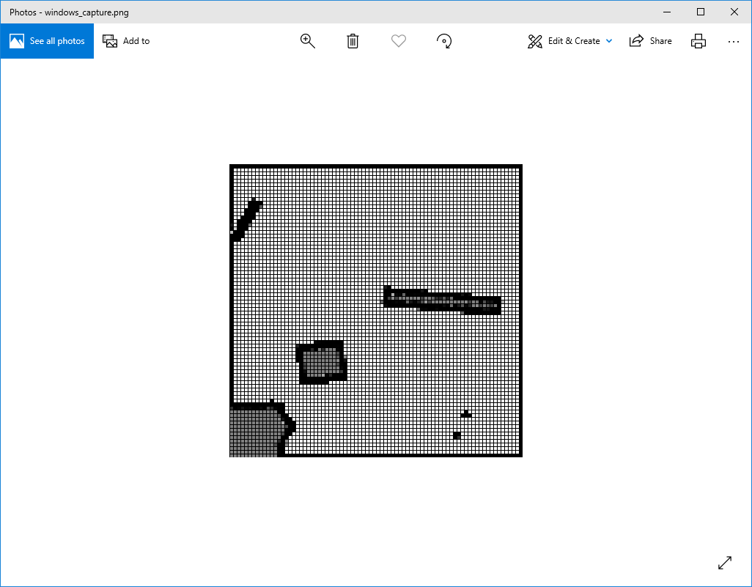

# Evaluation

## Objectives Met

These objectives are copied from the Analysis, with comments in red.

1. When started, a GUI must open Almost successfully implemented as described
   1. (Before it starts running) A button to open the configuration window
      1. An existing robot can be chosen
      2. A new robot can be created with different accuracy values
      3. A room is defined as a series of rectangle in form xpos, ypos, width, height, angle
      4. A preloaded room can be chosen
      5. A new room can be imported from a csv file
   2. (Before it starts running) A button to allow loading of a previously saved scan, to be resumed
   3. (Before it starts running) A start button that sends a 'start' command to the robot
   4. (While it is running) A stop button that stops the robot
   5. (While it is running or after it has finished running) A button to export the generated map to a format readable by an outside program (AutoCAD or similar, as specified by the client) only exports to a .png file
   6. (While it is running or after it has finished running) A button to save all details of the scan so far, to be able to be loaded later
2. 3 separate visualisation images must open, each displaying the environment in different ways Almost fully successfully implemented as described
   1. The first is generated by the simulation showing
      1. The exact location and direction of the robot
      2. The exact locations of each object placed in the environment
   2. The second is generated by the robot algorithm showing
      1. The assumed location and direction of the robot does not show the assumed direction
      2. The assumed location of each scan produced by the robot that iteration
      3. Any other point or line, as required by the algorithm the implemented algorithm does not require any other points or lines
   3. The third is the map that has been generated so far
      1. Divided into a grid, each square of variable size
      2. Each square will be a shade of grey, from white meaning definitely unoccupied to black meaning definitely occupied
3. The robot algorithm must run on the PC/Laptop and must Successfully implemented as described; the robot is implemented in hardware.py Hardware()
   1. send control messages to the robot
   2. receive readings from the robot
   3. send current status updates to the visualisation program (2nd and 3rd maps) these updates are sent by the robot, not the algorithm
4. The Robot must receive commands from the PC and act on them, returning the readings it makes These objectives are not to be implemented in this project, but it has been successfully abstracted into hardware.py Hardware() to allow easy editing, as intended
   1. It must be able to be run on a separate computer (i.e. a Raspberry Pi) that is on the same Wi-Fi network as the PC
   2. The details of how it becomes connected to the network is out of scope for this project
   3. For the purposes of this implementation, it will simulate it entirely from the PC
5. The simulation must implement the robot API Successfully implemented as described
   1. The 'move forward' and 'rotate' commands must move the internal 'true' value by a 'fuzzed' amount, instead of what was actually passed in, imitating an actual motor and wheel set
   2. The 'get sensor readings' command must return 360 values, one for each degree, representing the distance from the robot to the first object in that direction, but 'fuzzed' to imitate an imperfect laser reading
   3. The simulation must also send the 'true' position of the robot to the visualisation program

Generally, the program has fairly bad performance as there is an unintentional noticeable delay when moving the robot forwards, and it freezes for several seconds when loading maps, especially larger maps with a small square size (i.e. lots of squares). I anticipated that the calculations that happen each time the robot moves might be fairly computationally expensive, so I designed it so that they happened in a separate loop, to the GUI, so that the GUI would continue to process events during the calculations. However, in practice, these calculations were able to happen effectively instantaneously, and the considerable bottleneck was drawing all the points into the middle window and updating all the squares in the right window. I was able to somewhat optimise this by simply moving the points each time instead of recreating them from scratch, and I made it so that the squares would not update if they did not need to. These improvements noticeably improved the time it takes to update the simulation, but it is still far from ideal. Because this delay occurs when drawing objects to the screen, it must happen in the main GUI loop, which means that OS events are not being processed while this occurs, so minimising and moving the window cannot happen during the delay. If I had been aware that Qt QGraphicsScenes could not cope with such high numbers of items, a different GUI framework (such as the lower level OpenGL) may have been more appropriate.

## Extensibility / Potential for improvement

Support has been provided for extending the project past its current state in several places:

1. The Hardware class can be replaced with an interface for an actual piece of robot hardware, as long as it adheres to the same API defined above.
2. The RobotController.run() method currently just relays the controls input by the user to the hardware and acts upon them. It could be updated to the allow the robot to move itself automatically. A useful addition would be to find large concentrations of ‘gray’ squares (ie squares in the Cartographer grid with uncertain contents) and use a pathfinding algorithm such as A* to navigate to them, avoiding already-discovered obstacles.
3. Furthermore, any algorithm could be placed in RobotController.run() to improve the interpretation of the results. In particular, a SLAM (Simultaneous Location And Mapping) algorithm could be used to take into consideration the uncertainty generated after each movement, and convert it into a better map of the environment.

Other places which could see improvement include:

1. The export functionality could be improved to make the export more useful, such as being able to import it into CAD software, instead of being simply a .png image.
2. Making it manage the window size better, or allow resizing the window and scaling its contents down. In its current state, if the rooms loaded are too large, or the display too small, it spills out off the side of the screen, requiring the user to drag the window around in order to view the whole screen.

## Client Feedback

Whilst completing the technical solution, a work in progress version was shown to the client (see below). The client said that "the walls of the room should be shown on the left window." This resulted in a dark border being displayed around the left window, and a larger background square being used for the middle (right in the below) window to display dots that have been measured as outside the room. 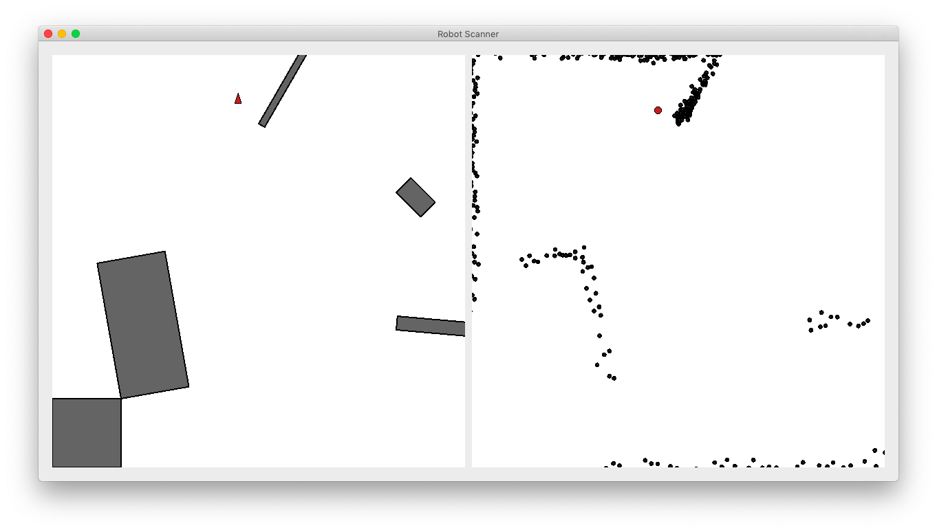

Upon completion, the client stated that “the project successfully meets almost all agreed-upon criteria. However, it is slow when running, which can make it frustrating to use with larger rooms. Not particularly intuitive: requires an explanation of how to use.”

The slowness is explained above, but overall the project has been a success, meeting the vast majority of objectives and passing all tests.

# Appendices

## Appendix 1 – Client Interviews

**Can you describe how you’d solve this problem (room mapping) without using this project? How will this project make it easier?**

Using tape measure and sketches, then drawn up on 2D drawing software. Assumptions would be made about right angles at corners, straightness of walls, and parallelism of opposite walls.

**What sort of rooms and objects in the rooms would you want the program to be able to detect and record (i.e. what use cases or potential use cases are you considering)?**

All kinds of rooms found in typical houses and flats. I would want it to measure up to walls/skirting boards, and to cope with fixed features such as hearths, built in cupboards, boxed in pipes, radiators, doorways, etc.

Should operate on carpet or hard floor surfaces and ideally be able to cope with rugs.

Might have to operate around some furniture - eg beds.

To map empty (or substantially empty) rooms more accurately and thoroughly than typical estate agent plans

- to confirm dimensions and layout in properties before purchase or after purchase

- to provide plans that can be used for purchasing flooring, furniture and for planning refurbishment work.

**What platform(s)/OS should the program support?**

Windows. But if you want it to be able to sell to a variety of customers a wider range may be needed.

**What type of output would you require? (A jpg/image file, vector file, a more detailed custom file including probabilities etc), and with detailed measurements?**

Something that can be uploaded into a drawing program, eg AutoCAD and Open Source equivalents.



1. <https://en.wikipedia.org/wiki/Monte_Carlo_localization>
2. <https://ocw.mit.edu/courses/aeronautics-and-astronautics/16-412j-cognitive-robotics-spring-2005/projects/1aslam_blas_repo.pdf>
3. <https://www.seeedstudio.com/RPLiDAR-A1M8-360-Degree-Laser-Scanner-Kit-12M-Range-p-3072.html>
4. <https://www.sparkfun.com/products/14756>
5. <https://www.python.org/downloads/release/python-368/>
6. <https://riverbankcomputing.com/software/pyqt/download5>
7. <https://sqlite.org/index.html>
8. <https://en.wikipedia.org/wiki/Logistic_function>